18th June 2021
Heyford Park School
Primary Newsletter
Dear Families
Newsletter
This week we have welcomed two more families to Heyford Park Primary Phase – welcome to Darcey in Year 6 and Sanvid in Year 1 – we hope you have had a good first week.

With the news that the Covid restrictions are not being lifted we are making plans at the moment for how we can carry out events over the next few weeks. We will let you know as we make concrete plans, but as you are aware, we cannot invite parents to watch Sports Day as we cannot go above 30 people gathering together in an outside space.

BE AN ILLUSTRATOR FOR THE DAY
Following our recent ‘Be an Illustrator for the day’ event, many of the children in Primary have spent time creating a new character for a yet-to-be-written children’s fiction series. The standard was impressive with some incredible creative entries! Below are the names of the children whose entries will be sent to Alex T. Smith (English author and illustrator of children's books, including Primrose, Egg, Ella, and the Claude book series) for judging. The top 3 entries from amongst all of the PiXL schools that have taken part will not only receive a signed copy of one of Alex’s books, but will also have their character digitalised by a professional designer! Good luck to you all and congratulations on representing HPS Primary!
Mrs Osbourne – English Lead

Year 1 | Bea  Kacy  James W  Fred  Albert  Elsie  Daisy  NB  Fyfe | Year 2 | Seth  Jack  Dylan  Leon  Isla  Juniper  Georgia  Charlotte  Honor | Year 3 | Kelly  Mayah G  Nell  Edward B  Jordan C  Lily  Cai  Lucas B  David P  Indi W
Year 4 | Teodor  Mithra  Ivy C  Cormac  Winifred  Lottie  Tenley  Poppy  Maisy  Molly T | Year 5 | Paris  Ella B  Lily B  Alba  Chloe H  Valentin  Daisy  Liam  Riley | Year 6 | Max D  Erin  Rafal S  Annabelle M-H  Ruby-May  Lucy  Yazmin  Madison  Nancy  Elsie

TRAVEL TO TOKYO
Since returning to school in March the children at HPS have been completing a 'Daily Mile' - 15 minutes of continuous movement each day. As a staff we have noticed that not only is this activity resulting in happier (and hopefully healthier!) children but that they are able to concentrate more effectively upon returning to class. We have now decided to add a challenge element - 'Travel to Tokyo!' With less than 50 days to go until the Olympic Games the school has been challenged to complete 5938 'Daily Miles' before the summer holidays - the equivalent distance of Bicester to Tokyo! Each week, the children will log their participation, creating a class total which will be shared in assembly on Friday. We would love for the children to continue to increase their class totals over the weekend - if your child completes a 'Daily Mile' please let their teacher know!
Miss Curtis – PE Lead

EURO 2020 BOOK COMPETITION

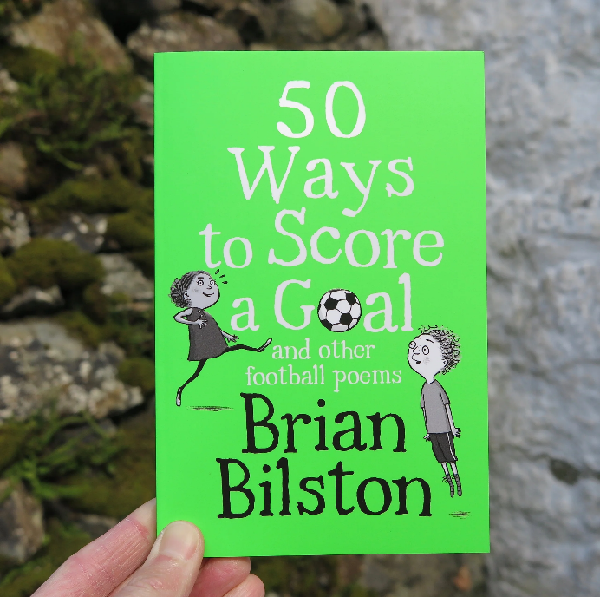
To celebrate the start of EURO 2020, Mr Marchant is offering three children the chance to win a very funny, new book of children's football poetry - 50 Ways to Score a Goal by Brian Bilston.

To enter this competition, you will need to write a letter to Mr Marchant explaining why you would like to win the book and telling him some fun things about football/EURO 2020. Mr M will be looking for letters that have been written with effort and passion (like a perfect keepie-uppie), that are smartly presented (like the England team) and that make him smile and laugh (like everyone does when Mr M tries to score a goal!) Letters should be handwritten and can be illustrated, decorated, rhyming or even written on a football.....the choice is yours, but the more fun the better!

To avoid getting a red card, Petr Chec (sorry, please check) your spelling and punctuation!

Children from all primary year groups can enter the competition. You have until the final whistle blows at the end of the day on Friday 25th June to get your finished letter to Mr Marchant. Letters can be left at the school office, handed to class teachers or delivered in person to Mr M. Mr Marchant will referee over the weekend and announce the champions the following week.

COME ON YOU GREENS!

CONGRATULATIONS
Well done to the following children who have received a certificate this week.
Year Group | Writing | Maths | Reading
Minibeasts | Amairah- for great progress in her handwriting. Amairah is working so hard to form her letters correctly. | Bethanie- for amazing progress in her understanding of number. | Indie- Indie is reading fluently and recognising most tricky words independently.
Tigers | Edi - For a fantastic character description on for his missing poster. | Astrid – for asking for help this week and learning from her mistakes | Jamie – for working really hard with Mrs Reynolds on his phonics
Kangaroos | James B - has become so independent, using his phonics to sound out new words. Not needing an adult and believing in himself. | Esmae- for being able to recognise coins and their value. Adding up coins to finds totals during mental maths. | Bea – for locating pages to retrieve the answers. Comparing books to others she has read.
Koalas | Honor – For working hard this week with writing a diary account of an explorer | McKenzie– For great work this week on position and direction and following instructions. | Brooke – For working hard on her reading and using her reading eggs account every morning.
Lions | Olly S – for a commitment to always making his writing the best that it can be. | Freddie - for putting 100% effort into our Maths assessment. Taking his time certainly paid off! | Jamie - for working hard to develop strategies to help himself in Guided Reading.
Otters | Brenn – for putting a lot of effort in to his setting description. It was nice to see you really motivated. | Edward – for trying really hard in his maths assessment and taking the time to read the question carefully. | Tobias – for being a keen reader. It is lovely to see him enjoying all the books in our classroom.
Pandas | Archie – for using some beautiful show not tell sentences in his descriptive writing | Maciej – for working extremely hard in his assessment and taking time and care over his checking of answers. | Lola – for challenging herself to use evidence from the text to support her answers
Brown Bears | Jenna - for fantastic work when completing a setting description of Westminster Abbey. The attention to detail and the way I felt as though I'd been there was so impressive! Keep up the great work Jenna! | Bobby - for his independence in Maths this week. | Ollie - for always working hard to read and understand text. He has been practicing for next week's PIXL tests and the effort he is putting into reading every question in detail is great. Well done, Ollie!
Polar Bears | Lilli D – For taking her time planning super sentences to go into her big write. | Henry – for working well in a group this week during maths and supporting his peers with tricky questions. | Liam – for being a super star during reading this week.
Bumble Bees | Lola - for her outstanding performance on the SPaG paper! | Max – for his incredible accumulation of 28 whole extra marks across 3 papers!  Noah – for his awesome accumulation of 25 whole extra marks across 3 papers! | Neema – for her outstanding performance on the Reading Paper!
Eagles |  | Theo, Mason and Molly for all making exceptional progress in maths throughout the year

Also the following children have received a Head Teacher’s award this week:
Minibeasts | Penelope- For being such a good friend. Penelope is always kind to others and someone who works hard every day. Everyone in Minibeasts enjoys playing with Penelope because looks after everyone and always follows the school rules.
Tigers | Felicity – for working extremely hard to challenge herself in her learning, and asking for help when needed.
Kangaroos | Albert- for always trying his best in all he does in class. Completing homework each week and enjoying it! I loved your favourite reading position on the trampoline reading to Dad whilst wrapped in a blanket.
Koalas | Juniper – For being a mature, friendly and helpful friend to her classmates.
Lions | Isla Mary – for being an amazing classmate.
Otters | Ivy – for impressing me this week with how maturely she has approached her assessments.
Pandas | Molly – for consistently being a fantastic model for others and for always following our school values
Brown Bears | JJJasmine - for being self-motivated, independent and always wanting to learn more! The definition of the words 'role model' - She is ready for secondary school, let alone year 6!
Polar Bears | Valentin – For showing the school values every day and always trying his best in lessons.
Bumblebees | Alena - for her outstanding leadership skills both within and outside the classroom this week!  Leo – for his outstanding performance on the final round of PiXL tests: such determination, resilience and enthusiasm!
Eagles | Darcey – for confidently joining Eagles in a tricky week of assessments and play rehearsals.

HOT CHOCOLATE FRIDAY
It was a delight once again to enjoy quality time with the nominated children from Year 3 and 4 for Hot Chocolate Friday. The children were chosen because they are always going above and beyond and demonstrating our school values. Well done to Alfie, Etta and Freddie in Lions; Win, Teo and Maisy in Pandas; and Blosson, Melanie and Tobias in Otters.
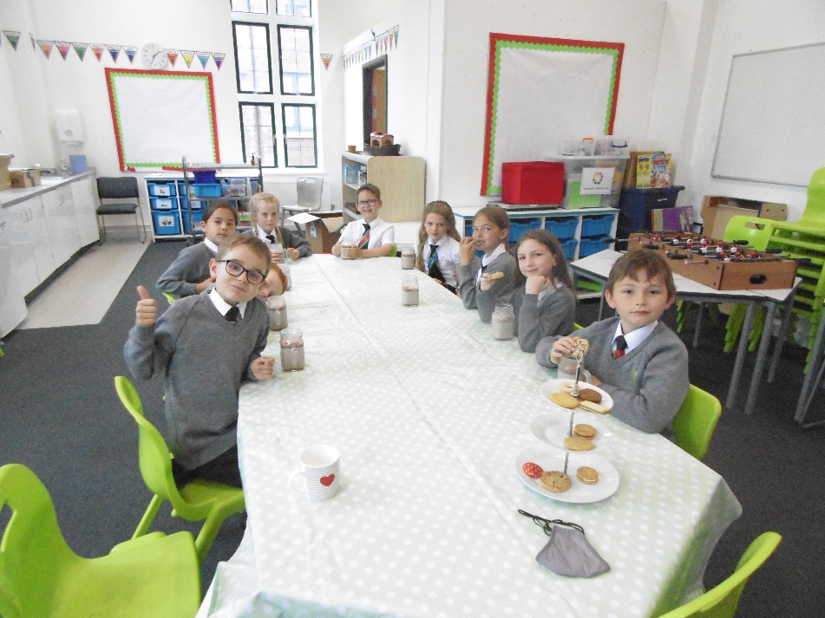

Best wishes and keep safe
Sarah Nickelson and the Primary Team.

Date | Time | Event | Location
Wednesday 23rd June 2021 | 6.00pm | Residential Meeting for Year 5 parents | Zoom – link has been sent to parents
Friday 25th June | All day – see timings | Sports Day  9.30 – 10.45am Nursery and Reception  11.00 – 12.30pm Key Stage One  1.00 – 3.00pm Key Stage Two  (please note change of time for end of the day for KS2) | Specialism Campus
Tuesday 29th June |  | School Photos – classes
Thursday 1st July | 6.00pm | New Reception Welcome Meeting | Held remotely
Friday 9th July | 9.30am – 2.00pm | Transition day – all children visiting new classes
 |  | Reports to go out to parents
Monday 12th – 16th July |  | Year 5 and 6 Bike-ability
Wednesday 14th July | 2.00pm  6.00pm | Year 6 Summer Play | Officers Mess
Tuesday 20th July | AM | Year 6 Graduation Ceremony | Officers Mess
Wednesday 21st July | 12.15pm | END OF YEAR

LIGHT THE LAKES EVENT
One of our parents is taking part in ‘Light the Lakes’ event – if you would like to support please see below.
The event see teams of police officers, staff and retired officers and police friends light up the famous Wainwright fells of Cumbria in memory of colleagues killed. There are 214 peaks and the aim is to have all of them lit with blue flares at 3am on the 19th June in memory of all fallen colleagues. Sgt Simon ‘Woody’ Woodman will be climbing the Great Gable peak, at just under 3000ft. Woody intends to increase the challenge by taking minimal food and water, relying on mountains natural sources. No shelter or sleeping bag!
A huge thank you to everyone who has already donated to this very special charity. There is still time to make a donation by visiting the Just Giving page.
https://justgiving.com/fundraising/ianwinter100?utm_source=Twitter&utm_medium=fundraising&utm_content=ianwinter100&utm_campaign=pfp-tweet&utm_term=a8f6478a693f4f3cad54984167f4c398

